The Problem with Tailless Wonders
Dr Hamish Baron BVSc (Hons) FANZCVS (Avian Medicine and Surgery bird vet)

At this time of year, there seems to be a discussion surrounding polyomavirus, beak and feather disease and the use of “Tailless Wonders” or budgies that have cracking heads and remarkable feather, but are missing a tail or flight feathers from the wings.
Each year I hear the same stories from breeders and in this article I’d like to dispel some of the myths.
Myth One
The feathers are missing because of a mite:
It is true that one of the causes of feather loss in birds can be a mite called quill mite belonging to the Syringophilopsis family, but these mostly occur in Passeriformes (those birds with three toes pointing forward and one backwards) and most of these mites live on the host and show no signs at all for their entire lifecycle.
Myth Two
If you pair one bird without flights and one bird with flights, the chicks will not have disease:
The two viruses that cause feather loss in budgerigars (polyomavirus and circovirus (beak and feather disease virus)) are transmitted in droppings, oral secretions, feather and skin dander, via dirt or dust in the nest box, burrowing mites and possibly via the egg – although this is not confirmed. So, if one parent has clinical disease (is missing flight feathers or a tail) and is shedding the virus, it is possible (and likely) that the chicks will become infected and will drop their flights and tail feathers at some stage during the breeding cycle.
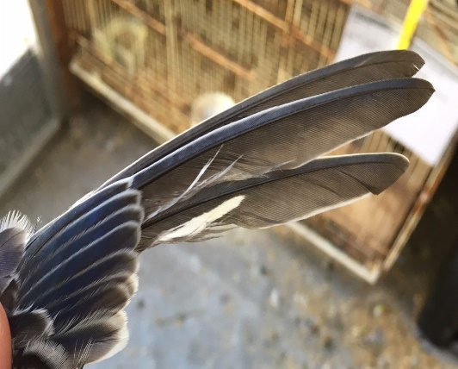
Myth Three
The loss of flight feathers is not a big deal because often they grow back:
This is partially true; if these chicks are infected with polyomavirus they will often grow their flight feathers back when they moult. However, polyomavirus causes much more than just loss of flight feathers. In a budgie aviary experiencing a disease outbreak, we expect to see a rise in the number of dead in shell (DIS) chicks that grow to full term and fail to hatch, an increase in the number of addled eggs (chicks that die mid-incubation), increased infant mortality at 6-10 days of age where apparently healthy chicks die for no reason.
Missing flight feathers.
Myth Four
Dipping affected birds in Virkon S or F10 SC will fix polyomavirus:
As discussed, the virus is transmitted in a number of different ways, and whilst dipping birds in a viricidal disinfectant will decrease the amount of virus on the birds’ feathers, it will not do anything to treat the virus, nor will it decrease shedding of the virus once the chick dries out. At present, the only effective “treatment” of polyomavirus is to stop breeding and allow all chicks to grow for six months, when they are no longer so susceptible. This effectively breaks the lifecycle of the virus and prevents young birds becoming a source of infection.

In order to prevent adult birds from shedding the virus it is important to provide low stress environments with low stocking densities, clean aviaries with high standards of hygiene. Bringing in new birds that have previously not been exposed to your aviary birds may facilitate infection (either transmission from the new birds or from your birds to the new bird) and so if you introduce a new bird to your flights, not breeding with them for six months will help to prevent outbreaks.
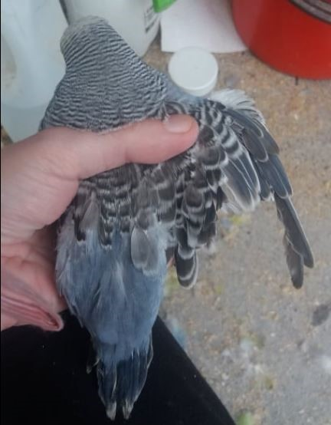
Breaking the polyomavirus cycle is frustrating and difficult. Frustrating because it means stopping breeding when you want to be producing chicks, and difficult because it requires a massive effort to clean and disinfect the aviary to prevent re-infection. In order to do this, you must remove all the organic material (dust, feathers, faeces) from the aviary, nesting boxes and breeding cages – this can then be followed by a viricidal disinfectant sprayed on and washed off with a cloth, before being sprayed on and allowed to dry on all surfaces. Allow all the chicks to mature to greater than 6 months old; any chicks that do not grow their flights back should be taken to a veterinarian for euthanasia to prevent ongoing disease transmission.
Missing both flight and tail feathers

Lastly, it is time that we as a hobby stop selling, gifting or otherwise using these birds with no primary feathers in the breeding room. If we eliminated this practice, those birds that are infected will not pass on the infection and we will work to reduce the infection rate and hopefully in the future we will not need to have the annual discussion about the cracking bird at home with no tail!
Acknowledgement
This article by Dr. Hamish Baron is supplied by the World Budgerigar Organisation (www.world-budgerigar.org), as part of their encouraged exchange of research information, and supplied to the WBO with kind permission by the Budgerigar magazine of The Budgerigar Society, U.K.

