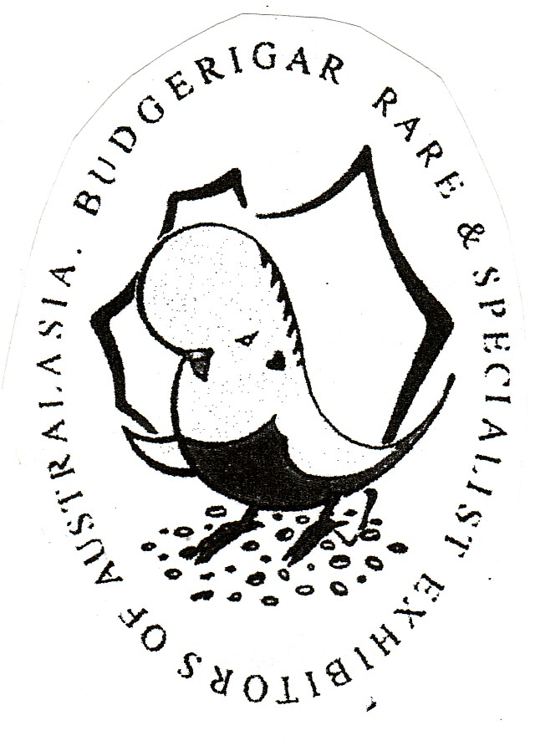
B.S.S.A. Ron Norman 74th Annual Show 2023
In conjunction with “BRASEA” State Show

Sunday 2nd April 2023

Westbourne Park Memorial Hall
388 Goodwood Road
WESTBOURNE PARK

This Show will be an ‘OPEN SHOW’
Any member financial with BSSA or any other Bird Society may show.

THIS IS A STATUS MOVEMENT SHOW

BIRDS NEED TO BE SPOTTED FOR THIS SHOW

Postal entries close with the Show Manager George England (0418 819 705) on Friday, 24th March, 2023. Email entries only to bssashowentry@gmail.com

Entry Fee : $1.00 per bird for the first 20 entered with payment for entries and postage to be made on show day.

Exhibitors to mark entries “I”, “N” or “J” depending on status.

EXHIBITORS WITH 15 BIRDS OR MORE AND TRAVELLING 50 KILOMETRES OR MORE TO THE SHOW VENUE WILL BE COMPENSATED $25.00.

NO LATE ENTRIES PLEASE. BE AWARE THAT PRIORITY MAIL IS NO LONGER AVAILABLE. A SECOND SET OF CAGE STICKERS WILL BE AVAILABLE SATURDAY MORNING IF THEY DON’T ARRIVE IN TIME.

BIRDS to be benched from 8.30 a.m. with Judging commencing at 9.30 a.m.

All exhibits to be presented in a standard Show Cages as approved by the ANBC except class 61 &62.

BSSA WILL ACCEPT CHROME OR POWDER COATED SHOW CAGES IN THIS SHOW.

All exhibits must have a closed ANBC ring except Classes 61 and 62.
No double or split rings as this constitutes a marked bird

BIRDS MAY NOT BE REMOVED BEFORE TROPHY PRESENTATION AT 2.00 PM

LUNCH IS PROVIDED

The Safety Officer has the right to reject entries prior to judging for signs of illness, deformity or poorly prepared Show Cages which are deemed hazardous or unhealthy to all the birds.

Birds are exhibited at the risk of the owner but the Show Committee will exercise all due care.

Cages to be fitted with a White D drinker ½ full with seed and fitted on the bottom wire near the door. White paper or plastic insert maybe used on the cage floor.
Equal parts Canary, Jap and White Millet are the only seeds permitted. Each cage to be fitted with a drinker (dry) with the position being four spaces in level with the perch. Stickers to be placed on the bottom left hand side of the Show Cage.

Four birds shall constitute a class. The Show Committee shall reserve the right to combine classes.

Hot Weather Policy:- In the event of the temperature being forecast 32c or above on the night before the Show (Channel 7 6.00 p.m. News) the Show will be cancelled. It will be the responsibility of the exhibitor to check the weather forecast.

RON NORMAN ANNUAL SHOW 2023- TROPHY LIST

MAJOR SPONSORS:- AVIAN VITALITY, YANKALILLA SEEDS/NATURE’S HARVEST, BRASEA AND ELENBEE BIRD SEEDS AND SUPPLIES

Total prize money $765.00

GRAND CHAMPION Trophy - $50.00 - Diploma
(AVIAN VITALITY VOUCHER)

RESERVE CHAMPION COCK Trophy - $20.00 – Diploma
RESERVE CHAMPION HEN Trophy - $20.00 - Diploma
THIRD CHAMPION COCK Trophy - $20.00 - Diploma
THIRD CHAMPION HEN Trophy - $20.00 - Diploma
FOURTH CHAMPION COCK Trophy - $20.00 - Diploma
FOURTH CHAMPION HEN Trophy - $20.00 - Diploma

CHAMPION INTERMEDIATE Trophy - $20.00 – Diploma
(AVIAN VITALITY VOUCHER) 10KG Premium Budgie Mix
Sponsored by Yankalilla Seeds/Nature’s Harvest

RESERVE INTERMEDIATE COCK Trophy - $10.00 – Diploma
RESERVE INTERMEDIATE HEN Trophy - $10.00 – Diploma

CHAMPION NOVICE Trophy - $20.00 – Diploma
(AVIAN VITALITY VOUCHER) 10KG Premium Budgie Mix
Sponsored by Yankalilla Seeds/Nature’s Harvest

RESERVE NOVICE COCK Trophy - $10.00 – Diploma
RESERVE NOVICE HEN Trophy - $10.00 – Diploma

NOVICE AWARD Most accumulated points - 20KG Premium Budgie Mix
Sponsored by Yankalilla Seeds/Nature’s Harvest

BEST JUNIOR EXHIBIT Trophy - $10.00 – Diploma

THIS IS A BRASEA CLEARWING CHALLENGE AND A GOLDEN CREST AWARD EVENT.

BEST OF VARIETY – Gold Breeders Award

32 Class winners receive $15.00 prize money

Best Normal Green Series Best Cinnamonwing
Best Normal Grey Green Best Spangle D/F
Best Normal Blue Series Best Opaline
Best Normal Grey Best Opaline AOSV
Best Normal Yellow Faced Blue Best Normal Spangle
Best Dilute Best Spangle AOSV
Best Lutino Best Dominant Pied
Best Albino Best Australian White Cap
Best Dk Eyed Clear Best AOSV/NSV

RON NORMAN STATE (BRASEA) SHOW 2022 - TROPHY LIST

BEST OF VARIETY – BRASEA

Best Normal Visual Violet Best Yellow Faced AOSV
Best Clearwing Best Greywing
Best Recessive Pied Best Crested
Best Blackeye Self Best Fallow
Best Lacewing Best Clearbody
Best Aust Golden Faced Blue Best Rainbow
Best Bush/Pet Budgie

Class Schedule

1 Normal Green Cock
2 Normal Green Hen
3 Normal Greygreen Cock
4 Normal Greygreen Hen
5 Normal Blue Cock
6 Normal Blue Hen
7 Normal Grey Cock
8 Normal Grey Hen
9 Normal Yellow Faced Blue Cock
10 Normal Yellow Faced Blue Hen
11 Dilute Yellow / White Cock
12 Dilute Yellow / White Hen
13 Lutino Cock
14 Lutino Hen
15 Albino Cock
16 Albino Hen
17 Dark Eyed Clear Cock
18 Dark Eyed Clear Hen
19 Cinnamonwing ASC Cock
20 Cinnamonwing ASC Hen
21 Spangle D/F ASC Cock
22 Spangle D F ASC Hen
23 Opaline ASC Cock
24 Opaline ASC Hen
25 Opaline AOSV ASC Cock
26 Opaline AOSV ASC Hen
27 Normal Spangle Cock
28 Normal Spangle Hen
29 Spangle AOSV Cock
30 Spangle AOSV Hen
31 Dominant Pied ASC/ASV Cock
32 Dominant Pied ASC/ASV Hen
33 Australian White Cap Cock
34 Australian White Cap Hen
35 AOSV/NSV Cock
36 AOSV/NSV Hen

Class 25 and 26 includes Black Eyed Self, Dilute, Clearwing, Greywing and Cinnamonwing.

Class 29 and 30 includes Greywing, Cinnamonwing, Opaline and Fallow.

Class 35 and 36 includes Dark Wing, Saddleback, Cinnamonwing Clearwings and Cinnamonwing Greywings.

D/F – Double Factor
S/F – Single Factor
NSV – Non Standard Variety

“BRASEA” Class Schedule

37 Normal Visual Violet Cock
38 Normal Visual Violet Hen
39 Normal Golden Faced Blue D/F
40 Normal Golden Faced Blue D/F
41 Black Eyed Self Cock
42 Black Eyed Self Hen
43 Clearwing ASC Cock
44 Clearwing ASC Hen
45 Greywing ASC Cock
46 Greywing ASC Hen
47 Clearbody ASC Includes Opaline Cock
48 Clearbody ASC Includes Opaline Hen
49 Lacewing ASC includes Opaline Cock
50 Lacewing ASC Includes Opaline Hen
51 Fallow ASC includes Opaline Cock
52 Fallow ASC Includes Opaline Hen
53 Recessive Pied ASC Cock
54 Recessive Pied ASC Hen
55 Crested ASC/ASV Cock
56 Crested ASC/ASV Hen
57 Rainbow Cock
58 Rainbow Hen
59 Yellow Faced/Golden Faced Blue S/F
AOSV Cock
60 Yellow Faced/Golden Faced Blue S/F
AOSV Hen
61 Bush or Pet Budgerigar ASC/ASV Cock
62 Bush or Pet Budgerigar ASC/ASV Hen

63 Junior ASC/ASV Cock
64 Junior ASC/ASV Hen

Class 39 and 40 is a Normal Australian Golden Faced Blue double factor. Normal Australian Golden Faced Blue single factor is to be shown in Classes 35 and 36.

Classes 59 and 60 includes all Yellow Faced/ Golden Faced combinations. Yellow faced combinations are not to be entered in Class 11 to Class 56 in an attempt to eliminate yellow intrusion and to assist Judges.

Class 61 and 62 can be non rung budgerigars
In any non standard cages, of any variety.

ASC – Any Standard Colour
ASV – Any Standard Variety
AOSV – Any Other Standard Variety

